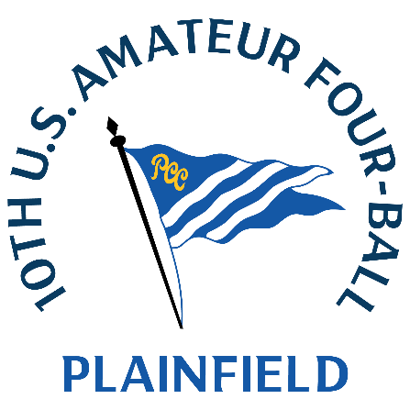
U.S. Amateur Four-Ball
Saturday, May 17, 2025
Plainfield Country Club
Echo Lake Country Club
Zach Capps &
Brent Whitehead
5-under 65 (first round, stroke play)

Q. Great round here at Plainfield. What was working for you?
Whitehead: I think we just hung in there all day. I think we did a good job keeping our focus throughout the whole day. Even when one partner was in a bad spot, I felt like we stayed in every hole.
Capps: I think we snuck in a couple that we maybe shouldn't have. You can get a good break in the rough and you have to take advantage and we got a couple good breaks coming home and we were able to actually get something that would hold the green and able to get a birdie look, but it was set up tough.
Q. You birdied three of the last four holes. How important was it to finish strong?
Capps: Yeah, we definitely both wanted to. We feel like we let one go on the back nine and we we were kind of telling ourselves, all right, let's get a couple more going home. And then we happened to sneak in another one. So it was just hanging with it. It's a strong finish.
Q. How do you guys know one another?
Whitehead: We were college teammates at Wofford back in the day. We have three Wofford players in the field this week. All the same year. It’s nice to see the Terriers hanging in there.

