
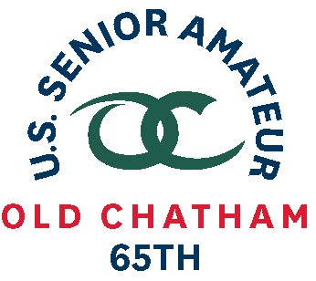
65th U.S. SENIOR AMATEUR CHAMPIONSHIP – Player Quotes

Aug. 24-29, 2019, Old Chatham Golf Club, Durham, N.C.

Greg Condon, Monte Vista, Colo.

First-Round Stroke Play (2-under 70)

“It’s damp. It’s wet, but it’s cool compared to the practice rounds. We didn’t really have this rain. It just started [as we were finishing]. The golf course was great. Hats off to the superintendent and the people here who are letting us play in their playground.” (on conditions)

“It was actually off to a bad start. I bogeyed the first hole (a par 5). Then all of a sudden I started playing OK. I had a chip-in on the second hole. I had a few more bad shots and then it started going good [with three consecutive birdies on Nos. 5-7]. I just really played solid [on the second nine] and made a mistake on the par-5 11th.”

“My son, Luke, is caddieing for me. He wanted to come and I need him here. Over the years, I’ve probably played better golf walking than riding. Maybe it is [more] time to think [between shots]. And your whole life, you’ve got that timing between shots.” [on walking versus riding)

“Friday, the 9th of August about 9 o’clock in the morning. Pretty exciting to get that call.” (on getting into the field as an alternate)

Co-medalist last year. That’s behind you. Trying to get into match play. Deepest ever gone is Round of 32 last year. Might have went to 16 one time in a Public Links.

Really small town. 5,000 people. One 9-hole course. 17 miles away is an 18-holer. Drive to and from every day. Leave the house at dark and practice in daylight until 7:30 in the morning. Back to work. After work, get back down there about 5:30 and do what I can do until the sun goes down.
Location in Southwest Colorado. Sun Country Amateur Golf Association (New Mexico)

